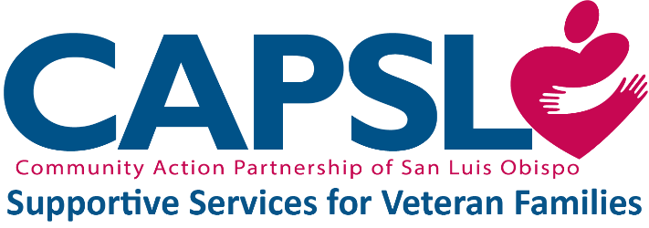
Supportive Services for Veteran Families (SSVF) Services Referral Form

Date: | Referred By (Case Manager):
Referral Agency/Program Name: | Case Manager Phone and Email:

Veteran Information

Name:

Date of Birth: | Gender:
Phone: | Email:
SLO County
HMIS Client ID #, if available:

This person served in the active military, naval, or air service, and was discharged or released therefrom under conditions other than dishonorable. Yes No (ineligible for SSVF)

Housing Status

Where does the applicant currently sleep? (please check one)

Owned by client, no housing subsidy
Owned by client, with housing subsidy
Permanent housing for formerly homeless
persons
Rental by client, no housing subsidy
Rental by client, with VASH housing subsidy
Rental by client, with other (non-VASH)
housing subsidy
Staying or living in a family member’s room,
apartment, or house
Staying or living in a friend’s room,
apartment, or house
Shared housing, with housing subsidy
Shared housing, no housing subsidy

Emergency shelter, including hotel or motel
paid for with emergency shelter voucher
Hospital (non-psychiatric)
Hotel or motel paid for without emergency
shelter voucher
Jail, prison, or juvenile detention facility
Place not meant for human habitation
inclusive of ‘non-housing service site (outreach program only)’
Psychiatric facility
Safe Haven
Substance abuse treatment facility
Transitional housing

Household Composition

Name | Relationship to Veteran | Gender | Date of Birth

Financial Information

Previously applied for and/or received SSVF assistance? Yes No
Currently receiving VA benefits and/or services? Yes No
Currently employed? Yes No

Monthly Income
Source: | Amount:
Source: | Amount:
Source: | Amount:
Source: | Amount:

Other relevant information:

To determine if the household meets the AMI requirement, locate the total number of household members in the top row and follow the column down to see if the total household income falls below the Area Median Income (50% Income Limit). Please indicate if the household falls below 30% or 50% AMI by circling the corresponding income limit box.
Total Household Members | 1 | 2 | 3 | 4 | 5 | 6 | 7 | 8
50% Income Limit | $31,500 | $36,000 | $40,500 | $44,950 | $48,550 | $52,150 | $55,750 | $59,350
30% Income Limit | $18,900 | $21,600 | $24,300 | $26,950 | $30,170 | $34,590 | $39,010 | $43,430

Authorization:
I hereby give my permission that the information contained on this form may be shared with the following SSVF agencies: Community Action Partnership San Luis Obispo County (CAPSLO), People Assisting the Homeless (PATH), Good Samaritan Shelter (Good Sam), 5Cities Homeless Coalition (5CHC).

____________________________________________ _______________
Veteran’s Signature Date

